Mission: Partnering with staff, students, and their families to create a safe, healthy, and inclusive learning environment that provides an enjoyable and positive experience for the entire school community.
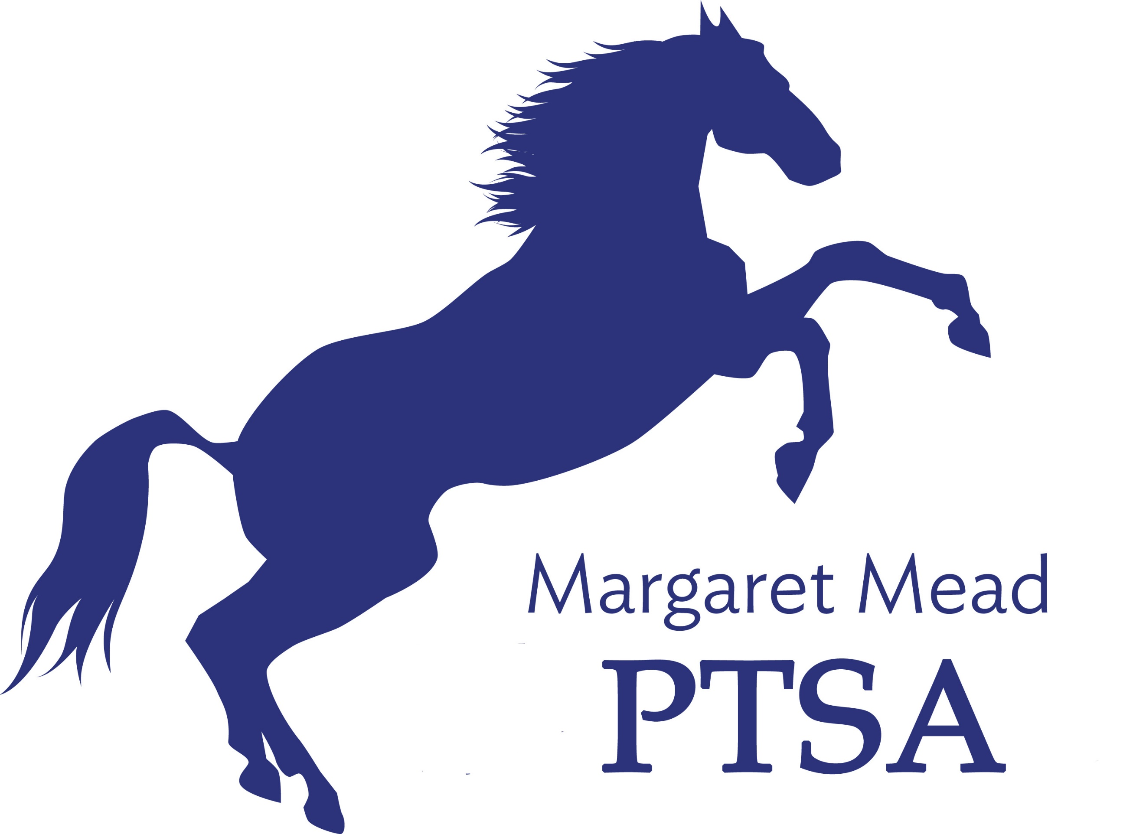
Margaret Mead Elementary PTSA
1725 216th AVE NE, Sammamish, WA 98074
PTSA Unit 2.8.38
www.meadptsa.org
Goal: Support the mission statement using
effective communication, connecting community, financial support & fiscal responsibility.

Board of Directors Meeting MINUTES January 14, 2021

Present: Leta Hamilton, Sarah Jensen, Ryika Hooshangi, Abi Nubla Kung, Antoinette Haynes, Ashley Arrington, Ashwini Godbole, Cassy Patterson, Daniella Toledo, Heather Gibbons, Liz Moore, Molly Hylen, Niko Olsen, Sharon Wu, Sue Gabica, Trista Lofti, Sandy Klein, Suzy Khendry

Call to Order 7:32
Approval of the Minutes – Minutes approved into record with no changes.

President Ryika Hooshangi opened the Board Meeting with “Word on the street.”
Parents are understandably discussing In-person vs. fully remote. Mrs. Klein was not a part of any of the discussions around how the days are being structured for in person learning. Remote students will still have access to library books. So far, Mead respondents have been split about 50/50 between those staying remote & those returning to in person learning. K-1 will be a half day 4 days a week. Safety Net teachers will be utilized as K-1 teachers. Safety Net is an extra support. It is not based on IEP plans. By early next week, teachers will have told the school whether they will come into the building or stay as remote teachers. District will be providing masks to children for in school. Could the PTSA provide mask hooks or some way for students to keep the masks on them? Leta Hamilton will explore some kind of “mask bag” that can be branded with Mead PTSA that we can give out to families.

Board Business:
Spirit wear – Wendy Bragalone will be setting up a Spirit Wear campaign to coincide with Return to School.

Feb. Board meeting date change – change to 7:30pm due to the Spelling Bee being that same evening.

Lake Washington PTSA Council awarded Mead with a YOU ROCK Award for our PTSA “How to…” series.

International Night is coming up in March. All board members are encouraged to give ideas to Ryika Hooshangi.

Bingo Night is Jan 21.

Spelling Bee is Feb 4.

Vice President, Abi Nubla-Kung, opened the discussion about a Diversity, Equity & Inclusion board member versus committee chairperson. Do we want to combine DEI (Diversity, Equity & Inclusion) with Advocacy? Should we make DEI a board position & make Sustainability a Committee chair? Sandy Klein’s email went out to the Mead community today. We can liaise with Sandy about who is interested and approach them about joining the BoD as a DEI. The BoD is going to make DEI a Committee position for now. Suzy Khedry motioned to make DEI a committee position. Abi Nubla-Kung seconded. Unanimous approval to make DEI a Committee position for now.

Treasurer: Molly Hylen, reported that $98,159.72 was the end balance for December. For door prizes for our virtual events, we can take the funds out of FACE line item. Another option, we have $15,000 that was earmarked for TBD. Suzy Khendry motioned to transfer $999 into the FACE line item from TBD line item. Heather Gibbons seconded. Motion passed unanimously.

For new teachers coming into the building for in person learning, they will be given $500 (1st/2nd year of teaching) or $300 if they’ve taught over 2 years.

Committee Reports

FACE: Liz Moore & Trista Lotfi
- Gingerbread House competition success! 158 students participated in the Gingerbread House competition. Drawing winners & FlipGrid were fun motivations for the kids.
- Mariners Night would be coming up in a non pandemic year.
- March 4th is International Night. It’s the only upcoming school wide event coming up other than Read-A-Thon.

Membership: Catherine Tian & Daniella Toledo
- Current Membership numbers – 126 paid memberships
- Winter Membership Drive – nothing this year

Fundraising: Sharon Mason & Ashley Arrington
- Read-A-Thon postponed – Originally Feb 22 for launch. We are going to change the date due to February now being the month where families are transitioning to hybrid, in-person, learning at Mead. Week of April 19 will be the week for the Read A Thon. This will be a mostly community building endeavor. Fundraising will be a component, but only for those families wishing to donate. Primary objective is to bring our school community together.
Communications: Heather Gibbons & Sharon Wu
- PTSA online directory update – no headway. Parents are the ones supposed to be updating the database.

Emergency Prep: Antoinette Haynes & Cassy Patterson
- Further to Cassy’s email about the Pillowcase project, we are going to hold off for now while we are transitioning to in person learning. We will wait until next year when we can do it in person.

- PTSA supplies kept on school property are technically school property. Any property housed on campus is property of the school unless there is a contract between the PTSA and the school.

- We have masks in the emergency supplies. It is believed that they do not need to be replaced right now as the District has said they are covering PPE requirements for the return to school.

Next Board Meeting—February 4, 2021 at 7:30pm

Upcoming Events
- Jan 21: BINGO/Game Night
- Feb. 4: Board Meeting
- Feb. 4: Spelling Bee
- March 4: International Night
- March 11: Board Meeting
- April 15: Board Meeting
- April 29: Virtual Cooking Class

